TRAINING SESSIONS

May 2nd, 2017
9:30-11:30 AM
PaTTAN East
Magnolia Room
333 Technology Drive,
Malvern, PA 19355

Or

May 2nd, 2017
1:00-3:00 PM
PaTTAN East
Magnolia Room
333 Technology Drive,
Malvern, PA 19355

To register for one of the sessions, please click and register at the link below by April 27, 2017:

http://scheduleme.link/2611/

Pennsylvania
Early
Learning Standards
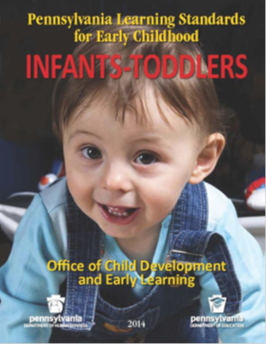
Infant/Toddler Early Intervention
Southeast Regional Training
2 Infant/Toddler Hours

You can download the Standards at http://www.pakeys.org/pages/get.aspx?page=Career-Standards
Presenters:

Roseann Adamo, Ken Crest

Fran Crowe, Arc Alliance

To register for the training click on the e-mail below:

http://scheduleme.link/2611/

Pennsylvania’s Early Learning standards provide the framework for learning. They provide the foundational information for what children should be able to know and do. Pennsylvania’s Learning Standards for Early Childhood build on information learned previously, crafting a continuum of learning that assures consistent and linked learning that begins in infancy, increasing in complexity as it extends through graduation

The Standards Aligned System is a collective body of research that identifies six elements which, when used together, provide a framework for program improvement and child success. Once of the elements identified is standards-these provide the framework for learning and the foundational information for what children should be able to know and do. This training will look at the 2014 Pennsylvania Learning Standards for Early Childhood: Infants-Toddlers
Objectives:

- Understand how the standards will support and enhance service delivery.

- Analyze and apply the resources provided in order to share the standards with programs and families.

- Easily access the Early Learning Standards materials using technology to assist in your work with children and families.

- Learn how to utilize, navigate and implement the materials as talking points with families and caregivers.

ody of researt identifies six elements which when us

